> groceries <- read.transactions(file.choose(),sep = ",",format = "basket")

> inspect(groceries[1:5])

items

[1] {citrus fruit,

margarine,

ready soups,

semi-finished bread}

[2] {coffee,

tropical fruit,

yogurt}

[3] {whole milk}

[4] {cream cheese,

meat spreads,

pip fruit,

yogurt}

[5] {condensed milk,

long life bakery product,

other vegetables,

whole milk}

> groceries@itemInfo

labels

1 abrasive cleaner

2 artif. sweetener

3 baby cosmetics

4 baby food

5 bags

6 baking powder

7 bathroom cleaner

8 beef

9 berries

10 beverages

11 bottled beer

12 bottled water

13 brandy

14 brown bread

15 butter

16 butter milk

17 cake bar

18 candles

19 candy

20 canned beer

21 canned fish

22 canned fruit

23 canned vegetables

24 cat food

25 cereals

26 chewing gum

27 chicken

28 chocolate

29 chocolate marshmallow

30 citrus fruit

31 cleaner

32 cling film/bags

33 cocoa drinks

34 coffee

35 condensed milk

36 cooking chocolate

37 cookware

38 cream

39 cream cheese

40 curd

41 curd cheese

42 decalcifier

43 dental care

44 dessert

45 detergent

46 dish cleaner

47 dishes

48 dog food

49 domestic eggs

50 female sanitary products

51 finished products

52 fish

53 flour

54 flower (seeds)

55 flower soil/fertilizer

56 frankfurter

57 frozen chicken

58 frozen dessert

59 frozen fish

60 frozen fruits

61 frozen meals

62 frozen potato products

63 frozen vegetables

64 fruit/vegetable juice

65 grapes

66 hair spray

67 ham

68 hamburger meat

69 hard cheese

70 herbs

71 honey

72 house keeping products

73 hygiene articles

74 ice cream

75 instant coffee

76 Instant food products

77 jam

78 ketchup

79 kitchen towels

80 kitchen utensil

81 light bulbs

82 liqueur

83 liquor

84 liquor (appetizer)

85 liver loaf

86 long life bakery product

87 make up remover

88 male cosmetics

89 margarine

90 mayonnaise

91 meat

92 meat spreads

93 misc. beverages

94 mustard

95 napkins

96 newspapers

97 nut snack

98 nuts/prunes

99 oil

100 onions

101 organic products

102 organic sausage

103 other vegetables

104 packaged fruit/vegetables

105 pasta

106 pastry

107 pet care

108 photo/film

109 pickled vegetables

110 pip fruit

111 popcorn

112 pork

113 pot plants

114 potato products

115 preservation products

116 processed cheese

117 prosecco

118 pudding powder

119 ready soups

120 red/blush wine

121 rice

122 roll products

123 rolls/buns

124 root vegetables

125 rubbing alcohol

126 rum

127 salad dressing

128 salt

129 salty snack

130 sauces

131 sausage

132 seasonal products

133 semi-finished bread

134 shopping bags

135 skin care

136 sliced cheese

137 snack products

138 soap

139 soda

140 soft cheese

141 softener

142 sound storage medium

143 soups

144 sparkling wine

145 specialty bar

146 specialty cheese

147 specialty chocolate

148 specialty fat

149 specialty vegetables

150 spices

151 spread cheese

152 sugar

153 sweet spreads

154 syrup

155 tea

156 tidbits

157 toilet cleaner

158 tropical fruit

159 turkey

160 UHT-milk

161 vinegar

162 waffles

163 whipped/sour cream

164 whisky

165 white bread

166 white wine

167 whole milk

168 yogurt

169 zwieback

> itemFrequencyPlot(x=groceries,topN=10)

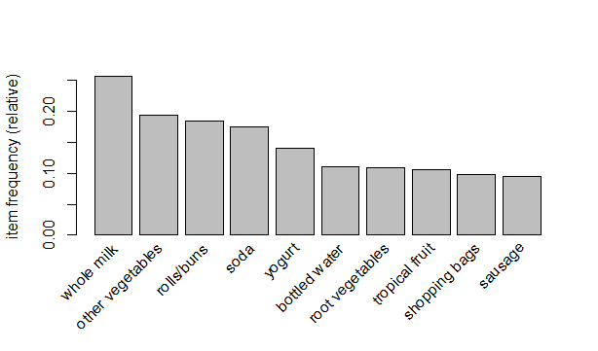

> grocerie_rules <- apriori(groceries,parameter = list(support =0.005,confidence=0.2,minlen = 3))

Apriori

Parameter specification:

confidence minval smax arem aval originalSupport maxtime support minlen maxlen

0.2 0.1 1 none FALSE TRUE 5 0.005 3 10

target ext

rules TRUE

Algorithmic control:

filter tree heap memopt load sort verbose

0.1 TRUE TRUE FALSE TRUE 2 TRUE

Absolute minimum support count: 49

set item appearances ...[0 item(s)] done [0.00s].

set transactions ...[169 item(s), 9835 transaction(s)] done [0.01s].

sorting and recoding items ... [120 item(s)] done [0.00s].

creating transaction tree ... done [0.01s].

checking subsets of size 1 2 3 4 done [0.00s].

writing ... [607 rule(s)] done [0.00s].

creating S4 object ... done [0.00s].

> grocerie_rules

set of 607 rules

> inspect(head(sort(grocerie_rules,by="lift")))

lhs rhs support confidence coverage lift count

[1] {citrus fruit,

other vegetables,

whole milk} => {root vegetables} 0.005795628 0.4453125 0.01301474 4.085493 57

[2] {butter,

other vegetables} => {whipped/sour cream} 0.005795628 0.2893401 0.02003050 4.036397 57

[3] {citrus fruit,

pip fruit} => {tropical fruit} 0.005592272 0.4044118 0.01382816 3.854060 55

[4] {other vegetables,

tropical fruit,

whole milk} => {root vegetables} 0.007015760 0.4107143 0.01708185 3.768074 69

[5] {whipped/sour cream,

whole milk} => {butter} 0.006710727 0.2082019 0.03223183 3.757185 66

[6] {root vegetables,

whole milk,

yogurt} => {tropical fruit} 0.005693950 0.3916084 0.01453991 3.732043 56

> inspect(head(sort(grocerie_rules,by="confidence")))

lhs rhs support confidence coverage lift count

[1] {root vegetables,

tropical fruit,

yogurt} => {whole milk} 0.005693950 0.7000000 0.008134215 2.739554 56

[2] {other vegetables,

pip fruit,

root vegetables} => {whole milk} 0.005490595 0.6750000 0.008134215 2.641713 54

[3] {butter,

whipped/sour cream} => {whole milk} 0.006710727 0.6600000 0.010167768 2.583008 66

[4] {pip fruit,

whipped/sour cream} => {whole milk} 0.005998983 0.6483516 0.009252669 2.537421 59

[5] {butter,

yogurt} => {whole milk} 0.009354347 0.6388889 0.014641586 2.500387 92

[6] {butter,

root vegetables} => {whole milk} 0.008235892 0.6377953 0.012913066 2.496107 81

> inspect(head(sort(grocerie_rules,by="support")))

lhs rhs support confidence

[1] {other vegetables,root vegetables} => {whole milk} 0.02318251 0.4892704

[2] {root vegetables,whole milk} => {other vegetables} 0.02318251 0.4740125

[3] {other vegetables,whole milk} => {root vegetables} 0.02318251 0.3097826

[4] {other vegetables,yogurt} => {whole milk} 0.02226741 0.5128806

[5] {whole milk,yogurt} => {other vegetables} 0.02226741 0.3974592

[6] {other vegetables,whole milk} => {yogurt} 0.02226741 0.2975543

coverage lift count

[1] 0.04738180 1.914833 228

[2] 0.04890696 2.449770 228

[3] 0.07483477 2.842082 228

[4] 0.04341637 2.007235 219

[5] 0.05602440 2.054131 219

[6] 0.07483477 2.132979 219

> inspect(head(sort(grocerie_rules,by=c("count","lift")))) #max count = 228

lhs rhs support confidence

[1] {other vegetables,whole milk} => {root vegetables} 0.02318251 0.3097826

[2] {root vegetables,whole milk} => {other vegetables} 0.02318251 0.4740125

[3] {other vegetables,root vegetables} => {whole milk} 0.02318251 0.4892704

[4] {other vegetables,whole milk} => {yogurt} 0.02226741 0.2975543

[5] {whole milk,yogurt} => {other vegetables} 0.02226741 0.3974592

[6] {other vegetables,yogurt} => {whole milk} 0.02226741 0.5128806

coverage lift count

[1] 0.07483477 2.842082 228

[2] 0.04890696 2.449770 228

[3] 0.04738180 1.914833 228

[4] 0.07483477 2.132979 219

[5] 0.05602440 2.054131 219

[6] 0.04341637 2.007235 219

> head(quality(grocerie_rules))

support confidence coverage lift count

1 0.005083884 0.5102041 0.009964413 1.996760 50

2 0.005083884 0.4504505 0.011286223 2.327998 50

3 0.005693950 0.6021505 0.009456024 3.112008 56

4 0.005693950 0.4000000 0.014234875 3.669776 56

5 0.006609049 0.4642857 0.014234875 1.817051 65

6 0.006609049 0.5462185 0.012099644 2.822942 65

> #plot methods matrix , mosaic , doubledecker , graph , paracoord , scatterplot , groupedmatrix , two-key plot , matrix3D ,iplots

> #visualisation

> plot(grocerie_rules,method = "scatterplot",jitter=0,col=colfunction(5))

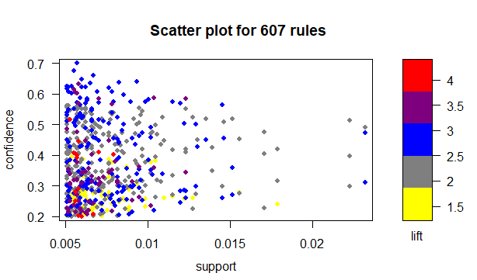

> plot(grocerie_rules,method = "grouped matrix",col=colfunction(5))

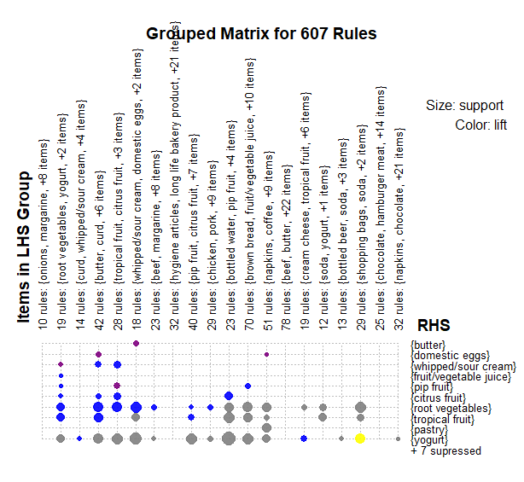

> plot(head(sort(grocerie_rules,by="support"),n=20),method="graph")

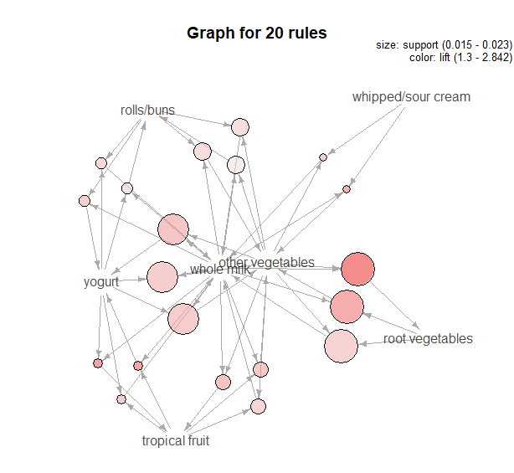

> plot(grocerie_rules,method = "paracoord")

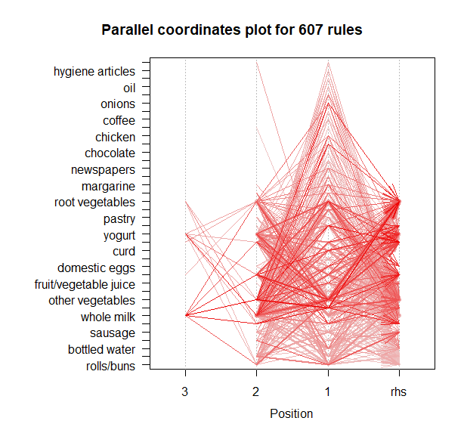

> plot(grocerie_rules,method = "matrix")

Itemsets in Antecedent (LHS)

[1] "{citrus fruit,other vegetables,whole milk}"

[2] "{other vegetables,tropical fruit,whole milk}"

[3] "{fruit/vegetable juice,other vegetables,whole milk}"

[4] "{citrus fruit,root vegetables,whole milk}"

[5] "{root vegetables,whole milk,yogurt}"

[6] "{root vegetables,tropical fruit,whole milk}"

[7] "{other vegetables,pip fruit,whole milk}"

[8] "{pip fruit,root vegetables,whole milk}"

[9] "{onions,root vegetables}"

[10] "{tropical fruit,whole milk,yogurt}"

[11] "{other vegetables,whipped/sour cream,whole milk}"

[12] "{curd,tropical fruit}"

[13] "{other vegetables,whole milk,yogurt}"

[14] "{root vegetables,whipped/sour cream,whole milk}"

[15] "{pip fruit,whipped/sour cream}"

[16] "{onions,whole milk}"

[17] "{tropical fruit,whipped/sour cream}"

[18] "{other vegetables,rolls/buns,whole milk}"

[19] "{fruit/vegetable juice,whole milk,yogurt}"

[20] "{butter,whipped/sour cream}"

[21] "{margarine,root vegetables}"

[22] "{pip fruit,whole milk,yogurt}"

[23] "{onions,other vegetables}"

[24] "{root vegetables,tropical fruit,yogurt}"

[25] "{other vegetables,pip fruit}"

[26] "{bottled beer,soda}"

[27] "{citrus fruit,root vegetables}"

[28] "{root vegetables,tropical fruit}"

[29] "{other vegetables,root vegetables,whole milk}"

[30] "{curd,other vegetables}"

[31] "{pip fruit,root vegetables}"

[32] "{whipped/sour cream,whole milk,yogurt}"

[33] "{fruit/vegetable juice,other vegetables}"

[34] "{butter,tropical fruit}"

[35] "{other vegetables,pip fruit,root vegetables}"

[36] "{butter,other vegetables}"

[37] "{pip fruit,yogurt}"

[38] "{butter,root vegetables}"

[39] "{whipped/sour cream,yogurt}"

[40] "{citrus fruit,tropical fruit}"

[41] "{rolls/buns,root vegetables,whole milk}"

[42] "{root vegetables,yogurt}"

[43] "{butter,whole milk}"

[44] "{citrus fruit,pip fruit}"

[45] "{cream cheese,whole milk}"

[46] "{citrus fruit,whipped/sour cream}"

[47] "{domestic eggs,root vegetables}"

[48] "{fruit/vegetable juice,root vegetables}"

[49] "{whipped/sour cream,whole milk}"

[50] "{root vegetables,whipped/sour cream}"

[51] "{frozen vegetables,other vegetables}"

[52] "{other vegetables,whipped/sour cream}"

[53] "{other vegetables,pip fruit,yogurt}"

[54] "{domestic eggs,pip fruit}"

[55] "{domestic eggs,whipped/sour cream}"

[56] "{domestic eggs,margarine}"

[57] "{chicken,root vegetables}"

[58] "{butter,domestic eggs}"

[59] "{other vegetables,yogurt}"

[60] "{other vegetables,tropical fruit,yogurt}"

[61] "{other vegetables,tropical fruit}"

[62] "{curd,root vegetables}"

[63] "{fruit/vegetable juice,other vegetables,yogurt}"

[64] "{chicken,whole milk}"

[65] "{frozen vegetables,root vegetables}"

[66] "{pastry,root vegetables}"

[67] "{citrus fruit,whole milk}"

[68] "{pip fruit,tropical fruit}"

[69] "{chicken,other vegetables}"

[70] "{butter,yogurt}"

[71] "{beef,whole milk}"

[72] "{domestic eggs,tropical fruit}"

[73] "{other vegetables,root vegetables,whipped/sour cream}"

[74] "{other vegetables,root vegetables,yogurt}"

[75] "{bottled water,butter}"

[76] "{pork,rolls/buns}"

[77] "{curd,yogurt}"

[78] "{cream cheese,other vegetables}"

[79] "{newspapers,root vegetables}"

[80] "{oil,whole milk}"

[81] "{pork,root vegetables}"

[82] "{margarine,whole milk}"

[83] "{citrus fruit,other vegetables}"

[84] "{curd,rolls/buns}"

[85] "{other vegetables,sugar}"

[86] "{root vegetables,sausage}"

[87] "{curd,whole milk}"

[88] "{rolls/buns,root vegetables}"

[89] "{domestic eggs,whole milk}"

[90] "{tropical fruit,yogurt}"

[91] "{beef,other vegetables}"

[92] "{tropical fruit,whole milk}"

[93] "{pork,whole milk}"

[94] "{other vegetables,root vegetables,tropical fruit}"

[95] "{rolls/buns,whipped/sour cream}"

[96] "{pip fruit,whole milk}"

[97] "{hamburger meat,whole milk}"

[98] "{curd,whipped/sour cream}"

[99] "{sausage,whipped/sour cream}"

[100] "{bottled beer,yogurt}"

[101] "{brown bread,root vegetables}"

[102] "{bottled water,sausage}"

[103] "{citrus fruit,other vegetables,root vegetables}"

[104] "{frozen vegetables,whole milk}"

[105] "{long life bakery product,whole milk}"

[106] "{butter,citrus fruit}"

[107] "{frankfurter,yogurt}"

[108] "{beef,yogurt}"

[109] "{sugar,whole milk}"

[110] "{domestic eggs,other vegetables}"

[111] "{other vegetables,whipped/sour cream,yogurt}"

[112] "{citrus fruit,domestic eggs}"

[113] "{frankfurter,tropical fruit}"

[114] "{cream cheese,yogurt}"

[115] "{chicken,rolls/buns}"

[116] "{root vegetables,shopping bags}"

[117] "{whole milk,yogurt}"

[118] "{sausage,tropical fruit}"

[119] "{hygiene articles,other vegetables}"

[120] "{other vegetables,whole milk}"

[121] "{fruit/vegetable juice,tropical fruit}"

[122] "{domestic eggs,yogurt}"

[123] "{hygiene articles,whole milk}"

[124] "{long life bakery product,other vegetables}"

[125] "{brown bread,tropical fruit}"

[126] "{root vegetables,whole milk}"

[127] "{beef,root vegetables}"

[128] "{beef,rolls/buns}"

[129] "{other vegetables,root vegetables}"

[130] "{bottled water,other vegetables}"

[131] "{bottled water,root vegetables}"

[132] "{other vegetables,pork}"

[133] "{frankfurter,whole milk}"

[134] "{frozen vegetables,yogurt}"

[135] "{butter,rolls/buns}"

[136] "{other vegetables,rolls/buns,yogurt}"

[137] "{newspapers,other vegetables}"

[138] "{coffee,yogurt}"

[139] "{pip fruit,sausage}"

[140] "{margarine,other vegetables}"

[141] "{citrus fruit,rolls/buns}"

[142] "{root vegetables,soda}"

[143] "{margarine,yogurt}"

[144] "{oil,other vegetables}"

[145] "{rolls/buns,whole milk,yogurt}"

[146] "{bottled water,yogurt}"

[147] "{other vegetables,rolls/buns,root vegetables}"

[148] "{pastry,tropical fruit}"

[149] "{sausage,shopping bags}"

[150] "{other vegetables,soda}"

[151] "{citrus fruit,yogurt}"

[152] "{brown bread,other vegetables}"

[153] "{bottled beer,whole milk}"

[154] "{margarine,rolls/buns}"

[155] "{frozen vegetables,rolls/buns}"

[156] "{frankfurter,root vegetables}"

[157] "{soda,yogurt}"

[158] "{other vegetables,rolls/buns}"

[159] "{fruit/vegetable juice,soda}"

[160] "{napkins,yogurt}"

[161] "{fruit/vegetable juice,yogurt}"

[162] "{sausage,yogurt}"

[163] "{sausage,whole milk}"

[164] "{other vegetables,sausage}"

[165] "{fruit/vegetable juice,whole milk}"

[166] "{pastry,yogurt}"

[167] "{rolls/buns,tropical fruit}"

[168] "{rolls/buns,shopping bags}"

[169] "{other vegetables,pastry}"

[170] "{rolls/buns,whole milk}"

[171] "{brown bread,yogurt}"

[172] "{domestic eggs,soda}"

[173] "{bottled water,tropical fruit}"

[174] "{coffee,other vegetables}"

[175] "{pastry,pip fruit}"

[176] "{rolls/buns,yogurt}"

[177] "{coffee,whole milk}"

[178] "{soda,whipped/sour cream}"

[179] "{napkins,other vegetables}"

[180] "{bottled beer,other vegetables}"

[181] "{bottled water,fruit/vegetable juice}"

[182] "{soda,tropical fruit}"

[183] "{frankfurter,other vegetables}"

[184] "{bottled water,citrus fruit}"

[185] "{napkins,whole milk}"

[186] "{pip fruit,rolls/buns}"

[187] "{soda,whole milk}"

[188] "{domestic eggs,rolls/buns}"

[189] "{newspapers,yogurt}"

[190] "{white bread,whole milk}"

[191] "{hamburger meat,other vegetables}"

[192] "{pastry,sausage}"

[193] "{napkins,rolls/buns}"

[194] "{other vegetables,shopping bags}"

[195] "{bottled water,rolls/buns}"

[196] "{sausage,soda}"

[197] "{brown bread,whole milk}"

[198] "{bottled water,whole milk}"

[199] "{chocolate,whole milk}"

[200] "{newspapers,whole milk}"

[201] "{chocolate,other vegetables}"

[202] "{newspapers,tropical fruit}"

[203] "{bottled beer,bottled water}"

[204] "{other vegetables,white bread}"

[205] "{pastry,whole milk}"

[206] "{brown bread,rolls/buns}"

[207] "{pastry,rolls/buns}"

[208] "{rolls/buns,soda}"

[209] "{newspapers,rolls/buns}"

[210] "{shopping bags,yogurt}"

[211] "{shopping bags,whole milk}"

[212] "{brown bread,soda}"

[213] "{bottled beer,rolls/buns}"

[214] "{shopping bags,soda}"

[215] "{fruit/vegetable juice,rolls/buns}"

[216] "{rolls/buns,sausage}"

[217] "{chocolate,soda}"

[218] "{pastry,soda}"

[219] "{bottled water,soda}"

[220] "{frankfurter,rolls/buns}"

Itemsets in Consequent (RHS)

[1] "{rolls/buns}" "{soda}" "{whole milk}"

[4] "{shopping bags}" "{other vegetables}" "{yogurt}"

[7] "{bottled water}" "{pastry}" "{sausage}"

[10] "{tropical fruit}" "{root vegetables}" "{citrus fruit}"

[13] "{pip fruit}" "{fruit/vegetable juice}" "{whipped/sour cream}"

[16] "{domestic eggs}" "{butter}"

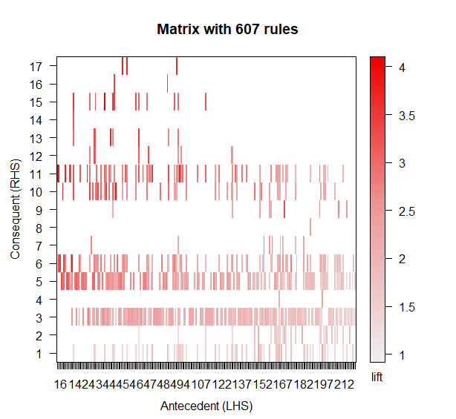

> # using different support and confidence

> grocerie_rules2 <- apriori(groceries,parameter = list(support=0.005,confidence = 0.5,minlen=2))

Apriori

Parameter specification:

confidence minval smax arem aval originalSupport maxtime support minlen maxlen

0.5 0.1 1 none FALSE TRUE 5 0.005 2 10

target ext

rules TRUE

Algorithmic control:

filter tree heap memopt load sort verbose

0.1 TRUE TRUE FALSE TRUE 2 TRUE

Absolute minimum support count: 49

set item appearances ...[0 item(s)] done [0.00s].

set transactions ...[169 item(s), 9835 transaction(s)] done [0.01s].

sorting and recoding items ... [120 item(s)] done [0.00s].

creating transaction tree ... done [0.00s].

checking subsets of size 1 2 3 4 done [0.01s].

writing ... [120 rule(s)] done [0.00s].

creating S4 object ... done [0.00s].

> grocerie_rules2

set of 120 rules

> inspect(head(sort(grocerie_rules2,by="lift")))

lhs rhs support confidence coverage lift count

[1] {curd,

tropical fruit} => {yogurt} 0.005287239 0.5148515 0.010269446 3.690645 52

[2] {citrus fruit,

root vegetables,

whole milk} => {other vegetables} 0.005795628 0.6333333 0.009150991 3.273165 57

[3] {pip fruit,

root vegetables,

whole milk} => {other vegetables} 0.005490595 0.6136364 0.008947636 3.171368 54

[4] {pip fruit,

whipped/sour cream} => {other vegetables} 0.005592272 0.6043956 0.009252669 3.123610 55

[5] {onions,

root vegetables} => {other vegetables} 0.005693950 0.6021505 0.009456024 3.112008 56

[6] {citrus fruit,

root vegetables} => {other vegetables} 0.010371124 0.5862069 0.017691917 3.029608 102

> inspect(head(sort(grocerie_rules2,by="confidence")))

lhs rhs support confidence coverage lift count

[1] {root vegetables,

tropical fruit,

yogurt} => {whole milk} 0.005693950 0.7000000 0.008134215 2.739554 56

[2] {other vegetables,

pip fruit,

root vegetables} => {whole milk} 0.005490595 0.6750000 0.008134215 2.641713 54

[3] {butter,

whipped/sour cream} => {whole milk} 0.006710727 0.6600000 0.010167768 2.583008 66

[4] {pip fruit,

whipped/sour cream} => {whole milk} 0.005998983 0.6483516 0.009252669 2.537421 59

[5] {butter,

yogurt} => {whole milk} 0.009354347 0.6388889 0.014641586 2.500387 92

[6] {butter,

root vegetables} => {whole milk} 0.008235892 0.6377953 0.012913066 2.496107 81

> inspect(head(sort(grocerie_rules2,by="support")))

lhs rhs support

[1] {other vegetables,yogurt} => {whole milk} 0.02226741

[2] {tropical fruit,yogurt} => {whole milk} 0.01514997

[3] {other vegetables,whipped/sour cream} => {whole milk} 0.01464159

[4] {root vegetables,yogurt} => {whole milk} 0.01453991

[5] {other vegetables,pip fruit} => {whole milk} 0.01352313

[6] {root vegetables,yogurt} => {other vegetables} 0.01291307

confidence coverage lift count

[1] 0.5128806 0.04341637 2.007235 219

[2] 0.5173611 0.02928317 2.024770 149

[3] 0.5070423 0.02887646 1.984385 144

[4] 0.5629921 0.02582613 2.203354 143

[5] 0.5175097 0.02613116 2.025351 133

[6] 0.5000000 0.02582613 2.584078 127

> inspect(head(sort(grocerie_rules2,by=c("count","lift")))) #max count = 219

lhs rhs support

[1] {other vegetables,yogurt} => {whole milk} 0.02226741

[2] {tropical fruit,yogurt} => {whole milk} 0.01514997

[3] {other vegetables,whipped/sour cream} => {whole milk} 0.01464159

[4] {root vegetables,yogurt} => {whole milk} 0.01453991

[5] {other vegetables,pip fruit} => {whole milk} 0.01352313

[6] {root vegetables,yogurt} => {other vegetables} 0.01291307

confidence coverage lift count

[1] 0.5128806 0.04341637 2.007235 219

[2] 0.5173611 0.02928317 2.024770 149

[3] 0.5070423 0.02887646 1.984385 144

[4] 0.5629921 0.02582613 2.203354 143

[5] 0.5175097 0.02613116 2.025351 133

[6] 0.5000000 0.02582613 2.584078 127

> #visualisation

> plot(grocerie_rules2,method = "scatterplot",jitter=0,col=colfunction(5))

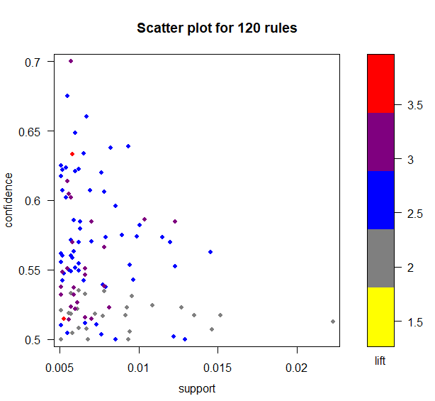

> plot(grocerie_rules2,method = "grouped matrix",col=colfunction(5))

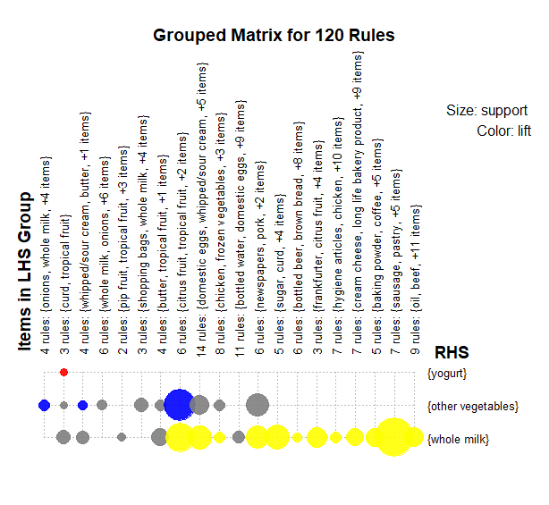

> plot(head(sort(grocerie_rules2,by="support"),n=20),method="graph")

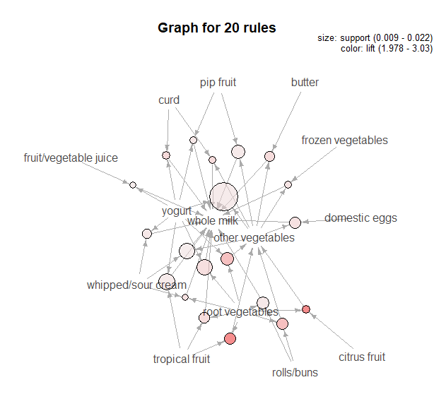

> plot(grocerie_rules2,method = "paracoord")

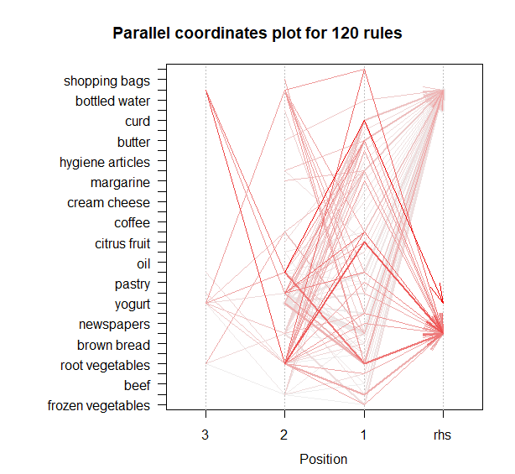

> plot(grocerie_rules2,method = "matrix")

Itemsets in Antecedent (LHS)

[1] "{citrus fruit,root vegetables,whole milk}"

[2] "{pip fruit,root vegetables,whole milk}"

[3] "{onions,root vegetables}"

[4] "{root vegetables,tropical fruit,whole milk}"

[5] "{curd,tropical fruit}"

[6] "{root vegetables,whipped/sour cream,whole milk}"

[7] "{pip fruit,whipped/sour cream}"

[8] "{onions,whole milk}"

[9] "{root vegetables,whole milk,yogurt}"

[10] "{fruit/vegetable juice,whole milk,yogurt}"

[11] "{butter,whipped/sour cream}"

[12] "{margarine,root vegetables}"

[13] "{pip fruit,whole milk,yogurt}"

[14] "{root vegetables,tropical fruit,yogurt}"

[15] "{root vegetables,shopping bags}"

[16] "{whipped/sour cream,whole milk,yogurt}"

[17] "{butter,tropical fruit}"

[18] "{other vegetables,pip fruit,root vegetables}"

[19] "{root vegetables,tropical fruit}"

[20] "{tropical fruit,whole milk,yogurt}"

[21] "{tropical fruit,whipped/sour cream}"

[22] "{butter,root vegetables}"

[23] "{citrus fruit,root vegetables}"

[24] "{butter,yogurt}"

[25] "{citrus fruit,whipped/sour cream}"

[26] "{domestic eggs,root vegetables}"

[27] "{fruit/vegetable juice,root vegetables}"

[28] "{pip fruit,root vegetables}"

[29] "{other vegetables,pip fruit,yogurt}"

[30] "{domestic eggs,pip fruit}"

[31] "{domestic eggs,whipped/sour cream}"

[32] "{domestic eggs,margarine}"

[33] "{chicken,root vegetables}"

[34] "{butter,domestic eggs}"

[35] "{other vegetables,tropical fruit,yogurt}"

[36] "{curd,root vegetables}"

[37] "{fruit/vegetable juice,other vegetables,yogurt}"

[38] "{frozen vegetables,root vegetables}"

[39] "{pastry,root vegetables}"

[40] "{root vegetables,yogurt}"

[41] "{domestic eggs,tropical fruit}"

[42] "{other vegetables,root vegetables,whipped/sour cream}"

[43] "{root vegetables,whipped/sour cream}"

[44] "{other vegetables,root vegetables,yogurt}"

[45] "{bottled water,butter}"

[46] "{newspapers,root vegetables}"

[47] "{rolls/buns,root vegetables}"

[48] "{pork,root vegetables}"

[49] "{curd,rolls/buns}"

[50] "{other vegetables,sugar}"

[51] "{curd,yogurt}"

[52] "{curd,other vegetables}"

[53] "{butter,other vegetables}"

[54] "{other vegetables,root vegetables,tropical fruit}"

[55] "{curd,whipped/sour cream}"

[56] "{sausage,whipped/sour cream}"

[57] "{bottled beer,yogurt}"

[58] "{brown bread,root vegetables}"

[59] "{citrus fruit,other vegetables,root vegetables}"

[60] "{butter,citrus fruit}"

[61] "{frankfurter,yogurt}"

[62] "{domestic eggs,other vegetables}"

[63] "{other vegetables,whipped/sour cream,yogurt}"

[64] "{pork,rolls/buns}"

[65] "{citrus fruit,domestic eggs}"

[66] "{frankfurter,tropical fruit}"

[67] "{chicken,rolls/buns}"

[68] "{frozen vegetables,other vegetables}"

[69] "{hygiene articles,other vegetables}"

[70] "{domestic eggs,yogurt}"

[71] "{margarine,rolls/buns}"

[72] "{rolls/buns,whipped/sour cream}"

[73] "{long life bakery product,other vegetables}"

[74] "{brown bread,tropical fruit}"

[75] "{cream cheese,yogurt}"

[76] "{pip fruit,yogurt}"

[77] "{whipped/sour cream,yogurt}"

[78] "{baking powder}"

[79] "{other vegetables,rolls/buns,yogurt}"

[80] "{beef,yogurt}"

[81] "{coffee,yogurt}"

[82] "{pip fruit,sausage}"

[83] "{sausage,tropical fruit}"

[84] "{other vegetables,pip fruit}"

[85] "{tropical fruit,yogurt}"

[86] "{pastry,yogurt}"

[87] "{root vegetables,sausage}"

[88] "{other vegetables,yogurt}"

[89] "{oil,other vegetables}"

[90] "{other vegetables,rolls/buns,root vegetables}"

[91] "{pastry,tropical fruit}"

[92] "{other vegetables,whipped/sour cream}"

[93] "{fruit/vegetable juice,yogurt}"

[94] "{frozen vegetables,rolls/buns}"

[95] "{beef,rolls/buns}"

[96] "{frankfurter,root vegetables}"

[97] "{brown bread,other vegetables}"

Itemsets in Consequent (RHS)

[1] "{whole milk}" "{other vegetables}" "{yogurt}"

